 | NEUROPHYSIOLOGICAL MEASURES RELATED TO SPECIFIC MENTAL AND EMOTIONAL STATES
 | Deliverable ID: | 4.1
 | Dissemination Level: | CO
 | Project Acronym: | ARTMATION
 | Grant: | 894238
 | Call: | H2020-SESAR-2019-01
 | Topic: | Digitalisation and Automation principles for ATM
 | Consortium Coordinator: | MDU
 | Edition date: | 13 May 2022
 | Edition: | 00.03.00
 | Template Edition: | 02.00.05

EXPLORATORY RESEARCH

Authoring & Approval
Authors of the document
Name / Beneficiary | Position / Title | Date
Pietro Arico' | PhD at UNISAP | 2021-12-21
Giulia Cartocci | PhD at UNISAP | 2022-01-05
Fabio Babiloni | Prof. at UNISAP | 2022-01-06
Gianluca Borghini | PhD at UNISAP | 2022-01-07
Gianluca Di Flumeri | PhD at UNISAP | 2022-01-07

Reviewers internal to the project
Name / Beneficiary | Position / Title | Date
Nicola Cavagnetto | Project Contributor | 2022-01-19
Minesh Poudel | Senior Research Engineer | 2022-01-26
Hamidur Rahman | Researcher, MDU | 2022-01-24

Reviewers external to the project
Name / Beneficiary | Position / Title | Date
Approved for submission to the SJU By - Representatives of all beneficiaries involved in the project
Name / Beneficiary | Position / Title | Date
Mobyen Uddin Ahmed | Coordinator/MDH | 2022-01-28
Christophe Hurter | Prof at ENAC | 2022-01-28
Fabio Babiloni | Full Prof. at UNISAP | 2022-01-28
Stefano Bonelli | Deep Blue | 2022-01-28

Rejected By - Representatives of beneficiaries involved in the project
Name and/or Beneficiary | Position / Title | Date

Document History
Edition | Date | Status | Name / Beneficiary | Justification
00.00.01 | 2021-12-21 | Draft | Pietro Aricò | With SJU template
00.00.02 | 2022-01-07 | Draft | Pietro Aricò/Giulia Cartocci/Fabio Babiloni/Gianluca Borghini/Gianluca Di Flumeri | Structure of the document
00.00.03 | 2022-01-26 | Draft | Nicola Cavagnetto/ Minesh Poudel/ Hamidur Rahman | Internal review
00.00.04 | 2022-01-27 | Draft | Pietro Aricò/Fabio Babiloni | Complete version with revision
00.01.00 | 2022-01-28 | Final for 1st round evaluation | Mobyen | Ready to submit to the System
00.02.00 | 2022-03-30 | 2nd round revision | Pietro Aricò | Ready to submit to the System
00.02.01 | 2022-05-11 | 3rd round revision | Pietro Aricò/Giulia Cartocci | Address SJU comments, and adapt the document in the new template
00.03.00 | 2022-05-13 | Final version | Mobyen | Review the ready for submission

Copyright Statement
© (2022) – (ARTIMATION Consortium). All rights reserved. Licensed to SESAR3 Joint Undertaking under conditions.

ARTIMATION
[ Transparent Artificial Intelligence and Automation to Air Traffic Management Systems]

This D4.1 “Neurophysiological measures related to specific mental and emotional states” is part of a project that has received funding from the SESAR Joint Undertaking under grant agreement No [894238] under European Union’s Horizon 2020 research and innovation programme.

Abstract
The present deliverable aims at describing the neurophysiological measures that will be employed during the validation activities to provide objective measures of effectiveness (i.e. mental workload and stress) and acceptability (approach-withdrawal) of XAI solutions. In particular, there will be reported the neurophysiological features that are responsive to the previously mentioned mental and emotional states, the processing chain to obtain those features, and the recording systems that will be used to record the related biosignals.

Table of Contents

Abstract 4
1 Neurophysiological measures 7
1.1 Neurophysiological measures in relation with project objectives 7
1.2 Electroencephalography – EEG 10
1.3 Galvanic Skin Response – GSR 14
2 Neurophysiological mental and emotional states assessment 16
2.1 Workload 16
2.2 Stress 16
2.3 Approach-Withdrawal 17
3 Biosignal processing 19
3.1 EEG processing chain 19
3.2 GSR processing chain 20
4 Biosignals recording systems 21
4.1 EEG Technology 21
4.2 GSR Technology 22
5 Conclusions 24
6 References 25

List of Tables
Table 1. List of objectives and success criteria for conflict resolution 7

List of Figures
Figure 1. Relation among stress, workload and performance 10
Figure 2. Graphical representation of cognitive spare capacity 10
Figure 3. 10-20 system for the standardized electrode placement 11
Figure 4. Comparison of EEG bands over one second of activity. Gamma (30-100Hz), Beta (12-30Hz), Alpha (8-12Hz), Theta (4-7Hz), and Delta (0-4Hz). 13
Figure 5. In the analysis of the GSR (or SC) two components are usually considered, the Skin Conductance level (SCL), and Skin Conductance Response (SCR). 15
Figure 6. ATCOs wearing an EEG cap 21
Figure 7. BE Micro EEG recording device 22
Figure 8. The figure shows the shimmer GSR recording device 23

List of Acronyms
Acronym | Definition
Ag/AgCl | Silver/Silver Chloride
AW | Approach-Withdrawal Neurometric
C | Central
CNS | Central Nervous System
ECoG | Electrocorticography
EDA | Electrodermal Activity
EEG | Electroencelography
F | Frontal
GFP | Global Field Power
GSR | Galvanic Skin Responce
Hz | Hertz
IAF | Individual Alpha Frequency
KΩ | Kilo ohm
MWF | Multi-channel Wiener Filter
O | Occipital
P | Parietal
PFC | Pre-Frontal Cortex
PPC | Posterior Parietal Cortex
SCL | Skin Conductance Level
SCR | Skin Conductance Response
SNS | Sympathetic Nervous System
VR | Virtual Reality
WL | Workload Neurometric
XAI | eXplainable Artificial Intelligence
μV | Micro-Volt

Neurophysiological measures
The following paragraph will describe from the theoretical point of view the neurophysiological measures related to mental and emotional states of interest for the purpose of the ARTIMATION project experimental validation. These neurophysiological measures will be employed to compare different XAI modalities in terms of effectiveness (i.e., Workload and Stress) and acceptability, or in other words the predisposition to use a specific modality or not (i.e., Approach Withdrawal).
Moreover, it will provide information regarding the signal processing necessary to obtain these measures from the collected bio signals (i.e., Electroencelography – EEG, Galvanic Skin Response – GSR). Some theoretical bases on EEG and GSR signals and related features that could be extracted from it will be also provided. First it will be defined how the consortium intends to use the neurophysiological measures to validate the project objectives.

Neurophysiological measures in relation with project objectives
Neurophysiological measures evaluation will be used during the experiments regarding the Conflict Resolution tool, to provide a comprehensive assessment of the different solutions tested during the experimental phases.
Below, Table 1 shows the conflict resolution objectives, reported also in the Deliverable 6.1.

Table 1. List of objectives and success criteria for conflict resolution
ID | Objective | Sub Objective | Methods | Success criteria
VO_CDR_1 | Assess the impact of different levels of transparency and different types of visualisations on acceptance | Level of understanding | Questionnaire | Positive controllers’ feedback
 |  | Level of agreement | Questionnaire | Positive controllers’ feedback
 |  | Level of acceptability | Questionnaire  Interviews | Positive controllers’ feedback
 |  |  | Neurometrics | High level of Approach-Withdrawal index
VO_CDR_2 | Assess the impact of different levels of transparency and different types of visualisations on human performance | Level of Usability | Questionnaire | Positive controllers’ feedback
 |  | Situation Awareness | Questionnaire | Positive controllers’ feedback
 |  | Trust | Questionnaire | Positive controllers’ feedback
 |  | Mental Workload | Neurometrics | Reduced/not increased workload/stress as level of transparency increases
 |  | Stress | Neurometrics
 |  | Task Performances | Log files from the simulator | Increasing/not decreased level of performance as transparency increases
VO_CDR_3 | Investigate the correlation between acceptance and human performance |  | All of the above | Variations in human performance are directly proportional to variations in acceptance.
VO_CDR_4 | Assess system performance | Expected impact on the safety | All of the above | Positive controllers' feedback
 |  | Expected impact on ATM system | All of the above | Positive controllers' feedback

As can be seen from the table above, Neurophysiological measures will be employed to cover three out of the four objectives expected from the validation (i.e., 1 to 3), and related success criteria. In fact, the acceptability, representing one of the three elements at the basis of the technology acceptance model defined by Davis [1] will be assessed by using the Approach-Withdrawal index. While Stress and Workload represent two out of the six elements composing the human performance of ATCOs that will be measured during the different experimental conditions (see D6.1 for further details). With regard to VO_CDR1, the it is expected to have higher level of Acceptance from the operator side (i.e. higher Approach-Withdrawal index) in correspondence of the level of transparency increase. Regarding the VO_CDR2, if the level of transparency increases, it is expected to not generate detrimental induced workload and stress levels (e.g., overload and overstress). With regard to VO_CDR_3, the working hypothesis that will be demonstrated during the project validation activities is that there could be a correlation between the technology acceptance and human performance (see Table 1 and Hypothesis 3 of the conflict resolution tool in the D6.1), meaning not only behavioural performance, but also workload and/or stress correlation. In this regard, the technology acceptance model (TAM, [1]) employed in the ARTIMATION project, suggests that the acceptance impacts on the degree to which a person believes that using a particular system would enhance their job performance.
With respect of just using subjective measures (e.g., questionnaires), one of the big advantages to have onboard the neurophysiological measures is the possibility to assess on time (e.g., second by second) the actual mental or emotional state of the user. So, it would be possible to assess during each experimental condition specific periods inducing mental and emotional states.
What ARTIMATION project will also investigate during the validation activities, is the co-variation among the different factors, that not necessarily have to go in the same direction (e.g., workload and stress both increasing too much). We would like to see if and when these human factors become unacceptable, i.e., if they negatively affect the performances. To provide practical examples, if by using two solutions it can be reached comparable levels of performances, it is preferrable the one in which workload and stress are in the optimal range (see Figure 1), but with lower values, to save available spare capacity of the operator (see Figure 2). On the contrary, those solutions in which the operator goes in under/over workload and/or under/over stress, so inducing decreasing in performances, should be avoided.

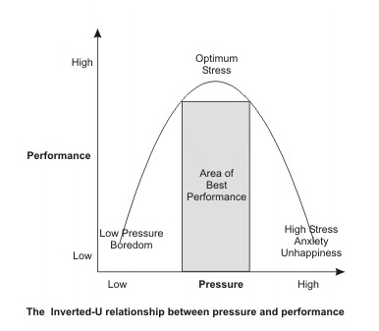 | 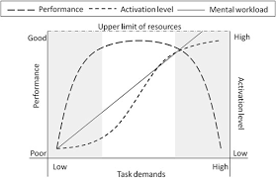
Figure 1. Relation among stress, workload, and performance
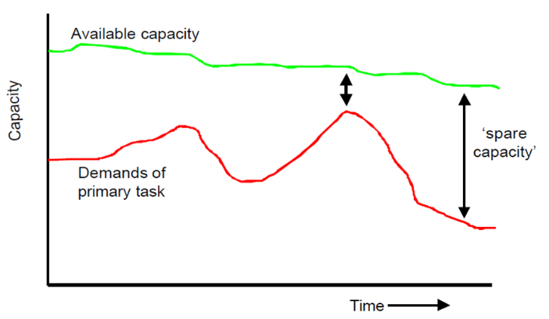
Figure 2. Graphical representation of cognitive spare capacity

Electroencephalography – EEG
The EEG is a recording of the brain’s electrical activity made from electrodes over the surface of the scalp (i.e., surface EEG) or from needle electrodes inserted into the brain (intracortical EEG). One of the first ever reports about EEG was by Richard Caton (1875[2]), who recorded the EEG oscillations from monkeys and rabbits. In 1929, Hans Berger [3] reported the first reliable recording of the EEG from a human scalp and a first categorization of EEG oscillation into alpha (8-13 Hz) and beta waves (14-30 Hz). Here, we refer EEG only to the signal measured from the head surface. Generally, the EEG recordings could be categorized into two types: the spontaneous activity and the evoked potentials. Spontaneous activity is often referred to the unprovoked occurrence of brain activity, in terms of the absence of an identifiable stimulus, with or without behaviour manifestation. The bandwidth of this signal is from under 1 Hz to over 100 Hz. The evoked potentials are time-locked components in the EEG that arise in response to a stimulus, which may be electric, visual, auditory, tactile, etc. Such signals are often evaluated by averaging several trials to improve the signal-to-noise ratio. EEG is measured using scalp electrodes, which record the difference in the electric potential between an electrode with an active neural signal and an electrode placed over a supposedly inactive region that serves as a reference (e.g., earlobes). These recordings are the resultant field potentials containing many active neurons. However, the action potential in axons is revealed to contribute little to the scalp surface records, as they are asynchronous while the axons run in many different directions. Surface records are thought to be the net effect of local postsynaptic potentials of the cortical cells. Mostly, the EEG measures the currents that flow during synaptic excitations of the dendrites of many pyramidal neurons, a type of neuron found in areas of the brain including the cerebral cortex [4]. Although there are various EEG recording systems in the market, such systems conventionally include four parts: electrodes with conductive gel, amplifiers with filters, A/D converter, and recording device. Electrodes are used to read the signal from the scalp; amplifiers increase the magnitude of the microvolt signals into a range which can be digitalized accurately; the converter changes the signals from analog to digital form; and the recorder system (normally personal computer) stores and displays the obtained data [4]. Additionally, a 10-20 system (Figure 3) EEG measurement has been adopted by the International Federation in Electroencephalography and Clinical Neurophysiology [5]. Such a system provides the standardized physical placement of electrodes on the scalp. The first part of derivation’s name indexes the array’s row—from the front of the head: Fp, F, C, P, and O. The second part is formed from numbers even on the left and odd on the right side, in the centre ‘‘z’’ or ‘‘0’’.
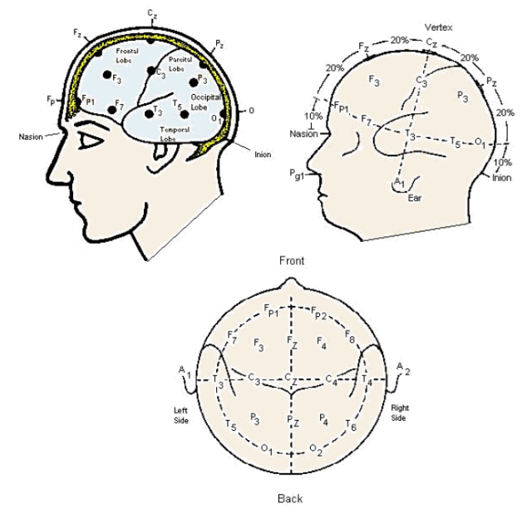
Figure 3. 10-20 system for the standardized electrode placement

Two basic approaches are commonly used for the EEG analysis: (i) the analysis of evoked potentials (EPs); and (ii) the power spectrum analysis (EEG rhythms). These two methods have been applied in various experimental or field research into human cognitive activities.
For ARTIMATION project, the second kind of EEG analysis (i.e., power spectrum analysis) has been employed.

EEG rhythms analyses
The oscillatory activity of the spontaneous EEG is typically categorized into five different frequency bands: delta (0-4 Hz), theta (4-7Hz), alpha (8- 12Hz), beta (12-30Hz) and gamma (30-100 Hz), as shown in Figure 4. These frequency bands are suggested to be a result of different cognitive functions.
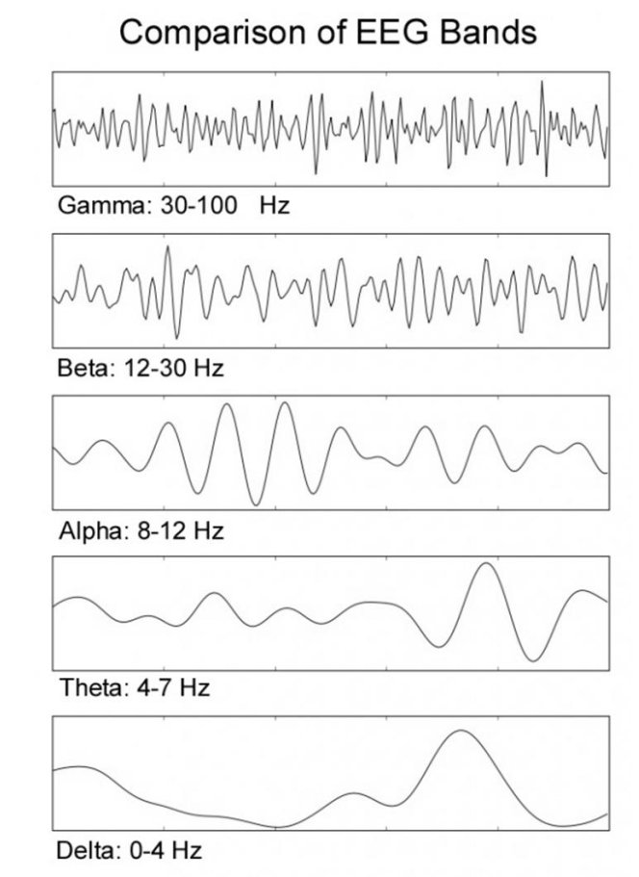
Figure 4. Comparison of EEG bands over one second of activity. Gamma (30-100Hz), Beta (12-30Hz), Alpha (8-12Hz), Theta (4-7Hz), and Delta (0-4Hz).

Delta activity is characterized by high amplitude and low frequency. It is usually associated with the slow wave in the psychophysiology of sleep. It is suggested that it represents the onset of deep sleep phases in healthy adults [6]. Theta rhythm is generally linked to the hippocampus activity [7] as well as neocortex [8]. It is thought to be linked to deep relaxation or meditation [9], and it has been observed during the transition between wake and sleep [10]. However, theta rhythms are suggested to be important for learning and memory functions [11], encoding and retrieval [12], which involve high concentration [10]. It has also been suggested that theta oscillations are associated with the attentional control mechanism in the anterior cingulated cortex [13], and it is often shown to increase with a higher cognitive task demand [14]. Alpha activity has found in the visual cortex (occipital lobe) during periods of relaxation or idling (eyes closed but awake). In the continuous EEG, the alpha band is characterized by high amplitude and regular oscillations, over parietal and occipital areas. High alpha power has been assumed to reflect a state of relaxation or cortical idling; however, when the operator assigns more effort to the task, different regions of the cortex may be recruited in the transient function network leading to passive oscillation of the local alpha generators, in synchrony with a reduction in alpha power [15]. Recent results have suggested that alpha is involved in auditory attention processes and the inhibition of task irrelevant areas to enhance the signal-to-noise ratio [16]. Additionally, alpha activity may be further divided into sub-bands by means of the frequency corresponding to the alpha peak of the user [16], called Individual Alpha Frequency (IAF). For instance, alpha 3 (IAF÷IAF+2 (Hz)) reflects semantic memory performance, while alpha 1 and alpha 2 (respectively, IAF-4÷IAF-2 and IAF-2÷IAF (Hz)) reflect general task demands and attentional processes. Beta activity is predominant in wakefulness state, especially in the frontal and central areas of the brain. High power in the beta band is associated with increased mental arousal and activity. Dooley [17] pointed out that the beta wave represents cognitive consciousness and active, busy, or anxious thinking. Furthermore, it has been revealed to reflect the visual concentration and the orienting of attention [18]. This band can be further divided into low beta wave (12.5-15 (Hz)), middle beta wave (15-18 (Hz)), high beta wave (> 18 Hz). Low waves seem to be associated with inhibition of phasic movements during sleep, and high waves with dopaminergic system [19]. Finally, Gamma is the fastest activity in EEG and it is thought to be infrequent during waking states of consciousness [17]. Recent studies reveal that it is linked with many cognitive functions, such as attention, learning, and memory [20]. Gamma components are difficult to record by scalp electrodes, because of their low amplitude, but with Electrocorticography (ECoG) components up to 100 (Hz), or even higher, may be registered.

Galvanic Skin Response – GSR
The signal related to the Skin Conductance, named hereafter Galvanic Skin Response (GSR), is recorded by means of specific sensors applied to the non-dominant hand [21]: by means of two electrodes on the first phalanx of the index and middle fingers, a constant potential is applied in order to induce a skin electrical current. The variations of such current are functions of the skin conductance variations. By a specific processing (i.e. Continuous Decomposition Analysis [22]) it can be possible to obtain two main components: the Tonic (Skin Conductance Level—SCL) and the Phasic (Skin Conductance Response—SCR) components of the GSR.
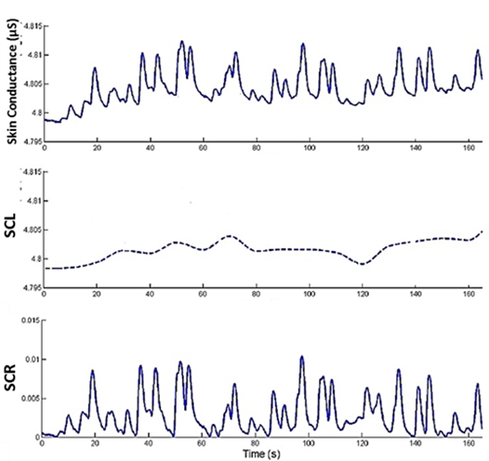
Figure 5. In the analysis of the GSR (or SC) two components are usually considered, the Skin Conductance level (SCL), and Skin Conductance Response (SCR).

In this regard, Boucsein [23] provided the most exhaustive review of GSR physiological interpretation and GSR analysis techniques. Briefly, there are two major components for GSR analysis: the SCL (tonic component) is a slowly changing part of the GSR signal, mostly related with the global arousal of a participant during a situation, whilst the SCR (phasic component) is the fast-changing part of the GSR signal, which occurs in relation to single stimuli reactions (Figure 3). An increase in skin conductance level is considered a reliable bioindicator of human arousal variations [24], it is typically used to evaluate the anxiety produced by a situation or the stress related to a threat [25]–[27].

Neurophysiological mental and emotional states assessment
This paragraph will report how neurophysiological measures can be employed to provide, even online, information regarding mental and emotional states of the user, regarding Workload, Stress and Approach-Withdrawal.

Workload
Various mental workload definitions have been given during the last decades, showing that workload is a complex construct resulting of different interacting cognitive aspects. Measurement of mental workload represents the quantification of mental activity resulting from performing a task. Several empirical investigations have indicated that performance declines at the extremes of the workload demand continuum - that is when the event rate is excessively high or extremely low. For these reasons, the mental workload is an important and central construct in ergonomics and human factor research. Moreover, the subjective measures of workload perception could be performed through several questionnaires, such as the NASA-TLX [28]. Because of their inherently subjective nature, questionnaires do not allow for an objective and reliable measure of the actual cognitive demand in a real environment. Therefore, it has already been demonstrated in several contexts that the assessment of mental workload by electroencephalography (EEG) provides the sought-after reliable and objective measure [29], [30].
This evidence showed that the brain electrical activities fundamental for the mental workload evaluation are the theta and alpha EEG rhythms, on the Pre-Frontal Cortex (PFC) and the Posterior Parietal Cortex (PPC) regions. The theta rhythm, especially over the PFC, presents a positive correlation - i.e. increases when the mental workload increases [31], while the alpha rhythm, especially over the PPC, presents an inverse correlation - i.e. decreases [32]. In recent studies [33]–[35], it has been demonstrated how it was possible to compute, by machine learning techniques and specific brain features, an EEG-based Workload Index able to significantly discriminate the workload demands during realistic tasks.

Stress
Stress is typical defined as a state that occurs when demand outstrips coping strategies [36]. In realistic context, it is easy to meet up stressful factors as high task demand, uncontrollability, frustration and time pressure and such stressors negatively influence performance altering cognitive processes at the base of decision-making, attention, and memory. Laboratory studies have been largely adopted to study correlates of stress using tasks and protocols that are proved to be able to induce stress in a controlled way. According to the literature [37], one of the most effective stressors consists in exposing a participant to a negative judgment. In fact, when negative feedbacks are provided to the participant, stressful sensations based on frustration will cause time pressure and make the task harder.
Classical biochemical markers for stress are cortisol and epinephrine, which will increase rapidly to stress exposure. However, it is difficult to measure the human cortisol level continuously and without interfering with the activities performed by the participant.
In this sense, a gold standard among the non-invasive measure of the stress level is the analysis of the skin conductance. In fact, when an individual is under mental stress, sweat gland activity is activated, thus reflecting in the skin conductance increasing. Since the sweat glands are also controlled by the Sympathetic Nervous System (SNS), skin conductance acts as an indicator for sympathetic activation due to the stress reaction [38]. In general, it has been widely demonstrated that the Skin Conductance, in both its two components the Skin Conductance Level (SCR) and Response (SCR), increases as the stress increases [39].
Finally, the EEG stress assessment is possible thanks to its high temporal resolution and the possibility to directly access to Central Nervous System (CNS) activity [40]. From this point of view, it has been assessed that in presence of stressors, there is decreasing alpha power in prefrontal cortex and increasing in beta in temporal and parietal sites [41]. Moreover, a correlation between cortisol and beta EEG band has been found [42]. In different contexts, it has been proved that stress condition induced brain activations asymmetry [43]: it has been demonstrated that the right brain hemisphere is mainly involved in cortisol production than the left hemisphere [44].
In relation with the previous project STRESS (GA699381), in which a comprehensive assessment of stress state from a neurophysiological point of view was provided, the Artimation project will test a lighter version of the Stress neurophysiological index, by using just few EEG sensors in the parietal part of the head [45]. This will have clear impact on future use of this technology in the ATM field, in which biosignals technology must be minimally invasive to be accepted and employed in operational field.

Approach-Withdrawal
Approach and withdrawal refer to how quickly and easily a person adjusts to changes or new situations. Some individuals may find it easy to adapt to new situations and are likely to jump in and meet new people or try new things. Others, whose style is withdrawing, tend to need more time to warm up to new situations; they may hang back before they join in. That’s why this concept could be very useful to assess the acceptability and consequent motivation towards a certain stimulus. A large body of research on the relation between emotion and motivation has postulated the existence of two overarching motivational systems that organize behavior. One system involves behavior prompted by a possible desirable outcome, whereas the other involves behavior prompted by a possible aversive outcome. A number of such models have been proposed, including Dickinson and Dearing's, 1979 [46] Aversive/Attractive systems, Gray's [47] Behavioral Activation/Behavioral Inhibition systems, and Lang et al.'s (1990)
Appetitive/Defensive systems. Davidson, 1983 [48] proposed a similar model linked to research on frontal EEG asymmetry during emotional states. He posited that frontal asymmetry was not related to the valence of an emotional stimulus but rather to the motivational system that is engaged by that stimulus. He proposed that the left PFC is involved in a system facilitating approach behaviour to appetitive stimuli, whereas the right PFC is involved in a system facilitating withdrawal behavior from aversive stimuli. During the experiments an Approach-Withdrawal neurophysiological index will be derived by the processing of the EEG signal on the PFC. Such index has been already employed in a variety of fields and conditions supporting its consistency, like experimental conditions characterized by a low-, a neutral and a high-approach positive mindset [49], the study of personality traits in children, [50], but also public service announcement [51] and neuroaesthetics [52]. Artimation is the first SESAR project in which this neurophysiological index will be validated in the ATM context, to assess an objective measure of acceptability from the operator side. This research will have a clear impact from an ergonomic point of view, e.g., during the testing of new HMIs and technologies, to assess in an objective way which is the degree of acceptability of the operator in front of the new solution.

Biosignal processing
In this section they will be explained the processing steps necessary to calculate the above-mentioned neurophysiological measures from the electroencephalographic (EEG) and Galvanic Skin Response (GSR) signals.

EEG processing chain
After that the EEG signal is band-pass filtered with a 5th-order Butterworth filter in the interval 2-30 Hz, the blink artifacts have to be detected by means of the Reblinca method [53] and corrected leveraging the ocular component estimated by means of Multi-channel Wiener Filter (MWF) [54]. EEG signals will then be segmented into epochs of 1 second and if the EEG signal amplitude exceeds ±80 (μV) it marked as artifact (threshold criterion).
From the artifact-free EEG, the Global Field Power (GFP) is calculated for each EEG frequency band (Theta, Alpha, Beta, Beta High). In this case, each band is defined accordingly with the Individual Alpha Frequency (IAF) value estimated for each participant [55]. Since the alpha peak is mainly prominent during rest conditions, the participants will be asked to keep their eyes closed for a minute before starting the experiment. Such a condition will be used to estimate the IAF value specifically for each participant. Consequently, the EEG bands are defined as:
- Theta= (IAF-6) : (IAF-2) Hz
- Alpha= (IAF-2) : (IAF+2) Hz
- Beta= (IAF+2) : (IAF+16) Hz
- Beta High= (IAF+11) : (IAF+16) Hz

For each mental state (Workload, Stress and Approach-Withdrawal) a subset of channels and bands of interest will be chosen according to the literature and results obtained from the previous EU projects [35], [51], [52], [56], [57].

The Workload neurometric is defined as:

$$WL=\frac{ Theta(Frontal Channels)}{ Alpha(Parietal Channels)}$$

The Stress neurometric is defined as:

$$Stress=BetaHigh (P3,P4)$$

The Approach-Withdrawal is defined as:

$$AW=Alpha \left(Frontal Dx\right)-Alpha (Frontal Sx)$$

GSR processing chain
The signal related to the Skin Conductance, named hereafter Galvanic Skin Response (GSR), will be recorded by means of two electrodes on the first phalanx of the index and middle fingers. A constant potential is applied to induce a skin electrical current. The variations of such current are functions of the skin conductance variations. The recorded signal will be down sampled (from 64Hz) to 8 Hz, to reduce the data amount. Secondly, the signal is filtered through a 5th order Butterworth low-pass filter, with the cut-off frequency at 2 Hz, to remove all the higher frequency components that are not related to the electrodermal activity, such as artifacts due to movements and fast high pressure on the electrode–skin contact surface. In particular, the latter causes fast and short signal peaks over the GSR signal: in this case a double-step procedure (automatic detection and expert visual check) will be applied in order to recognize the artefactual transient and to correct it by interpolating the corresponding signal through a piecewise cubic spline [58]. Then, the signal will be processed by using the Ledalab suite, a specific open-source toolbox implemented within MATLAB for the GSR processing: the Continuous Decomposition Analysis [22] will be applied in order to separate the Tonic (Skin Conductance Level—SCL) and the Phasic (Skin Conductance Response—SCR) components of the GSR. The mean value of the SCL during the experimental conditions will be employed as additional measure of stress.

Biosignals recording systems
This paragraph will introduce the technology that it is expected to be employed during the ARTIMATION validation activities to record the previously ascribed neurophysiological measures.

EEG Technology
Because in some of the conditions of the validation activities the participants must use a Virtual Reality system (e.g., Oculus VR), we chose an EEG technology compatible with the VR helmet, already validated during the MOTO project (GA969379), in which the participants must wear a VR helmet for all the experiment duration, lasting about 2 hours. The same technology was also employed already in many other research projects involving ATCOs (i.e., NINA, STRESS, MINIMA), demonstrating to not negatively affect the operational task.
In particular, EEG will be recorded by means of electrodes placed on the brain scalp following the traditional 10–20 electrode system [5] (Figure 6). Knowledge of the exact positions of electrodes is very important for both interpretation of a single recording as well as comparison of results, hence the need for standardization.
EEG electrodes can be produced with the shape of a cup, disc or needle, and are usually made of Silver (Ag) and Silver chloride (AgCl). Before placing the electrodes over the scalp, it is necessary to rub scalp skin with pastes or alcohol solutions, to remove all the substances and any kind of impurity generally present over the scalp epidermis. Then, traditional Ag/AgCl electrodes require an electrolyte gel that facilitates the transduction of the ionic currents between the skin and the electrode. Furthermore, the electrode-skin impedance must be controlled and adapted to achieve acceptable low values, typically 5 ÷ 20 KΩ [59].

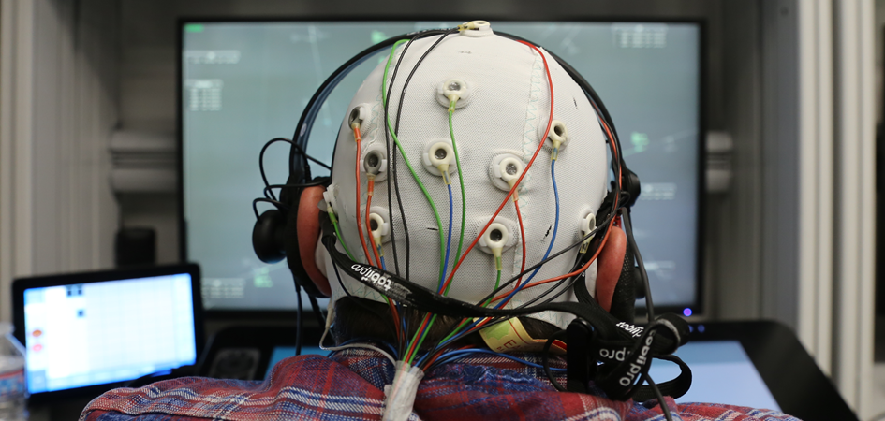
Figure 6. ATCOs wearing an EEG cap

The EEG recording device that will be employed is named BE Micro (from EB Neuro), it is reliable, compact, lightweight, durable, and most importantly comfortable for the user. BE Micro is fully capable of performing high quality conventional EEG and ambulatory EEG monitoring. The reduced dimensions (Figure 7), together with the EB Neuro high signal standard, make the Be Micro the polyfunctional system, not only for ambulatory/holter solution but also for EEG recordings in particular environments, such as air traffic control or aircraft cockpit. The BE Micro allows to record an EEG signal with a sampling frequency of 256 samples/second. The device is closed in a plastic box with an LCD display and it has 16 EEG channels.
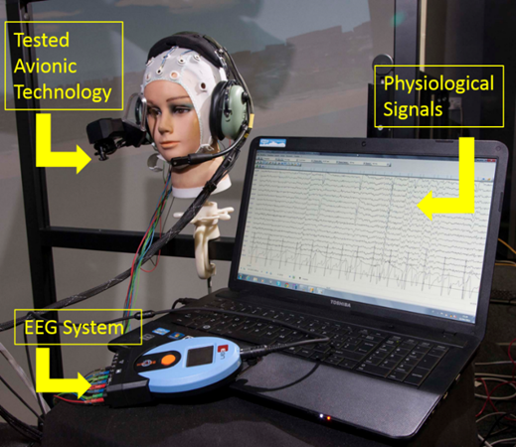
Figure 7. BE Micro EEG recording device

GSR Technology
In the context of ARTIMATION we aim to continuously monitor the GSR by using a wearable technology already employed during previous projects (i.e., NINA, STRESS, MINIMA) and demonstrating that the tool does not negatively affect the operator task execution. As mentioned above, the GSR is a well-accepted indicator of stress/arousal, and it can be captured by sweat gland phenomena. When an individual is aroused, sweat gland activity is activated and increases skin conductance. Since the sweat glands are also controlled by the sympathetic nervous system (SNS), skin conductance acts as an indicator for sympathetic activation [60]. The GSR recording system that will be employed in ARTIMATION is the Shimmer3 GSR, from Shimmer Sensing, reported in Figure 8. It provides connections and preamplification for one channel of Galvanic Skin Response data acquisition (Electrodermal Resistance Measurement – EDR/Electrodermal Activity (EDA) at a sample rate of 64Hz.
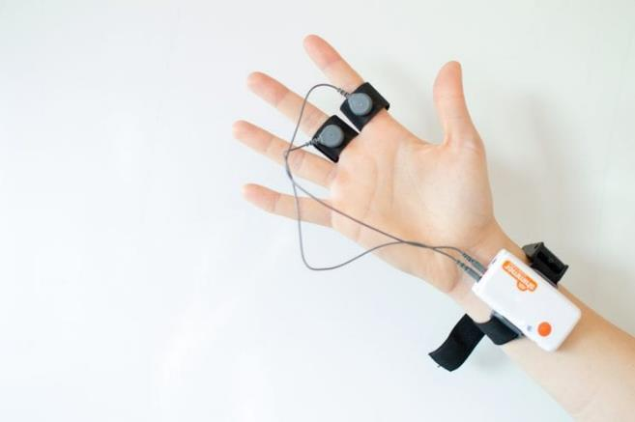
Figure 8. The figure shows the shimmer GSR recording device

Conclusions
This deliverable has been reported the background on neurophysiological measures that will be employed during the execution of the validation experiments. With respect to other kind of measures (i.e., subjective ones), neurophysiological ones have the big advantages to be objective, and to not distract the operator from the main task execution. In addition, these measures can be assessed even online, paving the possibility to realize smart interfaces (i.e., passive Brain-Computer Interfaces) that can adapt their behaviours to the actual operator state. For example, in the futuristic ATM solutions the neuro technology could trigger a specific XAI solution, depending on the actual workload level of the operator (e.g., if overloaded minimum level of explainable, maximum level on the contrary).
It is expected to use a technology already validated in many other Sesar projects (i.e., NINA, MOTO, STRESS, MINIMA), to be sure to not impact negatively on the operators’ task execution. Of course, before starting with the experiments (planned to be on the 2nd half of 2022), a pilot dry run will be performed to be sure that all the technology is still suitable with all the experimental constraints and compatible with all the employed additional technology needed to realize the specific XAI solution, to properly fine tune neuro-technology and related processing algorithms accordingly.

References
[1] F. D. Davis, “Perceived usefulness, perceived ease of use, and user acceptance of information technology,” MIS Q. Manag. Inf. Syst., vol. 13, no. 3, pp. 319–339, 1989.
[2] “Caton, Richard - The electric currents of the brain.” [Online]. Available: https://echo.mpiwg-berlin.mpg.de/ECHOdocuView?url=/permanent/vlp/lit27690/index.meta. [Accessed: 26-Jan-2022].
[3] L. F. Haas, “Hans Berger (1873–1941), Richard Caton (1842–1926), and electroencephalography,” J. Neurol. Neurosurg. Psychiatry, vol. 74, no. 1, pp. 9–9, Jan. 2003.
[4] M. Teplan, “Fundamentals of EEG measurement,” 2002. [Online]. Available: http://www.scribd.com/doc/47884335/FUNDAMENTALS-OF-EEG-MEASUREMENT. [Accessed: 08-Jan-2014].
[5] H. Jasper, “The ten twenty electrode system of the international federation,” Electroencephalogr. Clin. Neurophysiol., vol. 10, pp. 371–375, 1958.
[6] A. Kales, A manual of standardized terminology, techniques and scoring system for sleep stages of human subjects. Washington DC: United States Government Printing Office, 1968.
[7] G. Buzsáki, “Theta oscillations in the hippocampus,” Neuron, vol. 33, no. 3, pp. 325–340, Jan. 2002.
[8] J. L. Cantero, M. Atienza, R. Stickgold, M. J. Kahana, J. R. Madsen, and B. Kocsis, “Sleep-dependent theta oscillations in the human hippocampus and neocortex,” J. Neurosci. Off. J. Soc. Neurosci., vol. 23, no. 34, pp. 10897–10903, Nov. 2003.
[9] Y. Kubota et al., “Frontal midline theta rhythm is correlated with cardiac autonomic activities during the performance of an attention demanding meditation procedure,” Brain Res. Cogn. Brain Res., vol. 11, no. 2, pp. 281–287, Apr. 2001.
[10] K. Hagemann, “The alpha band as an electrophysiological indicator for internalized attention and high mental workload in real traffic driving.,” 2008. [Online]. Available: http://docserv.uni-duesseldorf.de/servlets/DocumentServlet?id=8318. [Accessed: 08-Jan-2014].
[11] G. Sammer et al., “Relationship between regional hemodynamic activity and simultaneously recorded EEG-theta associated with mental arithmetic-induced workload,” Hum. Brain Mapp., vol. 28, no. 8, pp. 793–803, Aug. 2007.
[12] L. M. Ward, “Synchronous neural oscillations and cognitive processes,” Trends Cogn. Sci., vol. 7, no. 12, pp. 553–559, 2003.
[13] M. E. Smith, A. Gevins, H. Brown, A. Karnik, and R. Du, “Monitoring task loading with multivariate EEG measures during complex forms of human-computer interaction,” Hum. Factors, vol. 43, no. 3, pp. 366–380, 2001.
[14] A. Gundel and G. F. Wilson, “Topographical changes in the ongoing EEG related to the difficulty of mental tasks,” Brain Topogr., vol. 5, no. 1, pp. 17–25, 1992.
[15] A. Gevins et al., “Monitoring working memory load during computer-based tasks with EEG pattern recognition methods,” Hum. Factors, vol. 40, no. 1, pp. 79–91, Mar. 1998.
[16] W. Klimesch, P. Sauseng, and S. Hanslmayr, “EEG alpha oscillations: the inhibition-timing hypothesis,” Brain Res. Rev., vol. 53, no. 1, pp. 63–88, Jan. 2007.
[17] C. Dooley, “The Impact of Meditative Practices on Physiology and Neurology: A Review of the Literature,” 2009, pp. 35–59.
[18] N. Birbaumer and R. . Schmidt, “Biologische Psychologie(3rd ed.),” 1996.
[19] K. Hagemann aus Ebersberg, G. mit der Genehmigung der, A. Buchner Koreferent, and P. Michael Schrauf, “The alpha band as an electrophysiological indicator to detect divided attention and high mental workload in real traffic drivi,” 2008.
[20] O. Jensen, J. Kaiser, and J.-P. Lachaux, “Human gamma-frequency oscillations associated with attention and memory,” Trends Neurosci., vol. 30, no. 7, pp. 317–324, Jul. 2007.
[21] F. Aloise, P. Aricò, F. Schettini, S. Salinari, D. Mattia, and F. Cincotti, “Asynchronous gaze-independent event-related potential-based brain-computer interface,” Artif. Intell. Med., vol. 59, no. 2, pp. 61–69, Oct. 2013.
[22] M. Benedek and C. Kaernbach, “Decomposition of skin conductance data by means of nonnegative deconvolution,” Psychophysiology, vol. 47, no. 4, pp. 647–658, 2010.
[23] W. Boucsein, Electrodermal activity, 2nd ed. New York: Springer, 2012.
[24] S. C. Jacobs et al., “Use of skin conductance changes during mental stress testing as an index of autonomic arousal in cardiovascular research,” Am. Heart J., vol. 128, no. 6, pp. 1170–1177, 1994.
[25] G. Riva, B. K. Wiederhold, and E. Molinari, “Virtual environments in clinical psychology and neuroscience: Methods and techniques in advanced patient-therapist interaction,” 1998.
[26] B. K. Wiederhold, R. Davis, and M. D. Wiederhold, “The effects of immersiveness on physiology,” Stud. Health Technol. Inform., pp. 52–62, 1998.
[27] B. K. Wiederhold et al., “An investigation into physiological responses in virtual environments: an objective measurement of presence,” Towar. cyberpsychology Mind, Cogn. Soc. internet age, vol. 2, pp. 175–183, 2001.
[28] S. G. Hart, “Nasa-Task Load Index (NASA-TLX); 20 Years Later,” Proc. Hum. Factors Ergon. Soc. Annu. Meet., vol. 50, no. 9, pp. 904–908, Oct. 2006.
[29] P. Aricò et al., “Adaptive Automation Triggered by EEG-Based Mental Workload Index: A Passive Brain-Computer Interface Application in Realistic Air Traffic Control Environment,” Front. Hum. Neurosci., vol. 10, p. 539, Oct. 2016.
[30] P. Aricò, G. Borghini, G. Di Flumeri, A. Colosimo, S. Pozzi, and F. Babiloni, “A passive Brain-Computer Interface (p-BCI) application for the mental workload assessment on professional Air Traffic Controllers (ATCOs) during realistic ATC tasks,” Prog. Brain Res. Press, 2016.
[31] G. Borghini et al., “Frontal EEG theta changes assess the training improvements of novices in flight simulation tasks,” in 2013 35th Annual International Conference of the IEEE Engineering in Medicine and Biology Society (EMBC), 2013, pp. 6619–6622.
[32] A. Gevins, M. E. Smith, L. McEvoy, and D. Yu, “High-resolution EEG mapping of cortical activation related to working memory: effects of task difficulty, type of processing, and practice,” Cereb. Cortex (New York, N.Y. 1991), vol. 7, no. 4, pp. 374–385, Jun. 1997.
[33] G. Borghini et al., “A neurophysiological training evaluation metric for Air Traffic Management,” in 2014 36th Annual International Conference of the IEEE Engineering in Medicine and Biology Society, 2014, vol. 2014, pp. 3005–3008.
[34] G. Borghini et al., “Avionic technology testing by using a cognitive neurometric index: A study with professional helicopter pilots,” in 2015 37th Annual International Conference of the IEEE Engineering in Medicine and Biology Society (EMBC), 2015, vol. 2015, pp. 6182–6185.
[35] P. Arico, G. Borghini, G. Di Flumeri, N. Sciaraffa, A. Colosimo, and F. Babiloni, “Passive BCI in Operational Environments: Insights, Recent Advances, and Future Trends,” IEEE Trans. Biomed. Eng., vol. 64, no. 7, pp. 1431–1436, Jul. 2017.
[36] “Hobfoll, S. E., & Shirom, A. (1993). Stress and burnout in the workplace conservation of resources. In R. T. Golembiewski (Ed.), Handbook of organizational behavior (pp. 41-60). New York M. Dekker. - References - Scientific Research Publishing.” [Online]. Available: https://www.scirp.org/(S(czeh2tfqyw2orz553k1w0r45))/reference/ReferencesPapers.aspx?ReferenceID=354005. [Accessed: 28-Jan-2022].
[37] N. Skoluda et al., “Intra-individual psychological and physiological responses to acute laboratory stressors of different intensity,” Psychoneuroendocrinology, vol. 51, pp. 227–236, Jan. 2015.
[38] H. Sequeira, P. Hot, L. Silvert, and S. Delplanque, “Electrical autonomic correlates of emotion,” Int. J. Psychophysiol., vol. 71, no. 1, pp. 50–56, Jan. 2009.
[39] W. Boucsein, Electrodermal activity. Springer Science+Business Media, LLC, 2012.
[40] G. Borghini et al., “A multimodal and signals fusion approach for assessing the impact of stressful events on Air Traffic Controllers,” Sci. Rep., vol. 10, no. 1, pp. 1–18, Dec. 2020.
[41] F. Al-Shargie, M. Kiguchi, N. Badruddin, S. C. Dass, A. F. M. Hani, and T. B. Tang, “Mental stress assessment using simultaneous measurement of EEG and fNIRS,” Biomed. Opt. Express, vol. 7, no. 10, p. 3882, Oct. 2016.
[42] S.-H. Seo and J.-T. Lee, “Stress and EEG,” Converg. Hybrid Inf. Technol., Mar. 2010.
[43] Z. H. Murat, M. N. Taib, Z. M. Hanafiah, S. Lias, R. S. S. A. Kadir, and H. A. Rahman, “Initial investigation of brainwave synchronization after five sessions of horizontal rotation intervention using EEG,” Proc. 2009 5th Int. Colloq. Signal Process. Its Appl. CSPA 2009, pp. 350–354, 2009.
[44] R. S. Lewis, N. Y. Weekes, and T. H. Wang, “The effect of a naturalistic stressor on frontal EEG asymmetry, stress, and health,” Biol. Psychol., vol. 75, no. 3, pp. 239–247, Jul. 2007.
[45] N. Sciaraffa et al., “Validation of a Light EEG-Based Measure for Real-Time Stress Monitoring during Realistic Driving,” Brain Sci. 2022, Vol. 12, Page 304, vol. 12, no. 3, p. 304, Feb. 2022.
[46] “APPETITIVE-AVERSIVE INTERACTIONS AND INHIBITORY PROCESSES | A. Dickins.” [Online]. Available: https://www.taylorfrancis.com/chapters/mono/10.4324/9781315802435-12/appetitive-aversive-interactions-inhibitory-processes-dickinson-boakes. [Accessed: 28-Jan-2022].
[47] P. Ekman and R. J. Davidson, “The Nature of Emotion: Fundamental Questions.” 1994.
[48] “Affect, cognition, and hemispheric specialization. - PsycNET.” [Online]. Available: https://psycnet.apa.org/record/1988-98011-011. [Accessed: 28-Jan-2022].
[49] E. Harmon-Jones, C. Harmon-Jones, M. Fearn, J. D. Sigelman, and P. Johnson, “Left frontal cortical activation and spreading of alternatives: tests of the action-based model of dissonance,” J. Pers. Soc. Psychol., vol. 94, no. 1, pp. 1–15, Jan. 2008.
[50] D. Kimura, “Brain asymmetry.,” Contemp. Psychol., vol. 17, no. 10, pp. 556–557, Oct. 1972.
[51] G. Cartocci et al., “Neurophysiological Measures of the Perception of Antismoking Public Service Announcements Among Young Population,” Front. Hum. Neurosci., vol. 12, Aug. 2018.
[52] G. Cartocci et al., “NeuroDante: Poetry Mentally Engages More Experts but Moves More Non-Experts, and for Both the Cerebral Approach Tendency Goes Hand in Hand with the Cerebral Effort,” Brain Sci., vol. 11, no. 3, pp. 1–25, Mar. 2021.
[53] G. Di Flumeri, P. Aricó, G. Borghini, A. Colosimo, and F. Babiloni, “A new regression-based method for the eye blinks artifacts correction in the EEG signal, without using any EOG channel,” in Engineering in Medicine and Biology Society (EMBC), 2016 IEEE 38th Annual International Conference of the, 2016, pp. 3187–3190.
[54] B. Somers, T. Francart, and A. Bertrand, “A generic EEG artifact removal algorithm based on the multi-channel Wiener filter,” J. Neural Eng., vol. 15, no. 3, p. 36007, 2018.
[55] W. Klimesch, “EEG alpha and theta oscillations reflect cognitive and memory performance: a review and analysis,” Brain Res. Brain Res. Rev., vol. 29, no. 2–3, pp. 169–195, Apr. 1999.
[56] G. Cartocci et al., “Electroencephalographic, Heart Rate, and Galvanic Skin Response Assessment for an Advertising Perception Study: Application to Antismoking Public Service Announcements,” J. Vis. Exp., vol. 2017, no. 126, Aug. 2017.
[57] P. Arico et al., “Human Factors and Neurophysiological Metrics in Air Traffic Control: a Critical Review,” IEEE Rev. Biomed. Eng., vol. PP, no. 99, pp. 1–1, 2017.
[58] C. De Boor and C. De Boor, A practical guide to splines, vol. 27. springer-verlag New York, 1978.
[59] “Noise Reduction Techniques in Electronic Systems : Ott, Henry W.: Amazon.it: Libri.” [Online]. Available: https://www.amazon.it/Noise-Reduction-Techniques-Electronic-Systems/dp/0471850683. [Accessed: 28-Jan-2022].
[60] H. Sequeira, P. Hot, L. Silvert, and S. Delplanque, “Electrical autonomic correlates of emotion,” Int. J. Psychophysiol., vol. 71, no. 1, pp. 50–56, Jan. 2009.

